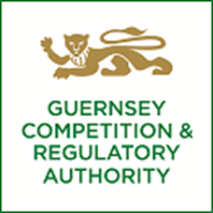

**NOTICE OF APPLICATION FOR APPROVAL OF AN ACQUISITION**

|  |  |
| --- | --- |
| Applicants: | Cinven Limited and Grant Thornton UK LLP and Grant Thornton UK Advisory & Tax LLP. |
| Proposed acquisition: | Cinven’s investment in Grant Thornton UK LLP and Grant Thornton UK Advisory & Tax LLP by companies ultimately managed by Cinven Limited. |
| Industries involved: | Accounting services, advisory, tax and audit professional services. |

The Guernsey Competition and Regulatory Authority (GCRA) invites comments regarding the proposed acquisition. The deadline for comments is 5 p.m. on 27 January 2025. Please send any comments by e-mail to info@gcra.gg and clearly marked “Cinven/Grant Thornton UK M1707G”. A public version of the merger application form is available on request.

**13 January 2025**